**R Code for Examples in the book**

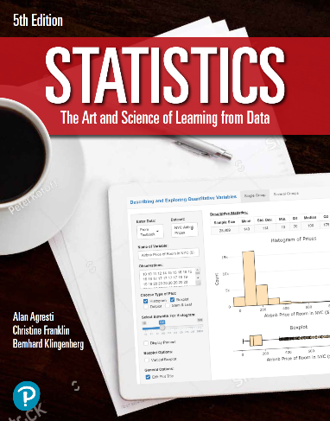

***“Statistics: The Art and Science of Learning from Data”***

**by Agresti, Franklin and Klingenberg, 5th edition**

**Chapter 12**

**Example 13: College GPA – Using Residuals to Check Model Assumptions**

## Reading in data:

students <- read.csv(file='https://raw.githubusercontent.com/artofstat/data/master/Chapter12/ga_student_survey.csv')  
colnames(students) # check column names

## [1] "Height" "Gender" "Haircut" "Job"   
## [5] "Studytime" "Smokecig" "Dated" "HSGPA"   
## [9] "CGPA" "HomeDist" "BrowseInternet" "WatchTV"   
## [13] "Exercise" "ReadNewsP" "Vegan" "PoliticalDegree"  
## [17] "PoliticalAff"

## Fitting regression model

linReg <- lm(CGPA ~ HSGPA, data = students)  
linReg

##   
## Call:  
## lm(formula = CGPA ~ HSGPA, data = students)  
##   
## Coefficients:  
## (Intercept) HSGPA   
## 1.1898 0.6369

## To obtain standardized residuals

mystdres <- rstandard(linReg)  
head(mystdres)

## 1 2 3 4 5 6   
## -1.1921565 -1.5092691 1.7105551 -0.5545109 0.0548887 1.7297650

## To create a histogram of the standardized residuals

hist(mystdres, col = 'darkgreen', main = 'Histogram', xaxt = 'n',  
 xlab = 'Standardized Residuals', ylab = 'Frequency')  
axis(1, at = seq(-4, 4, 1))

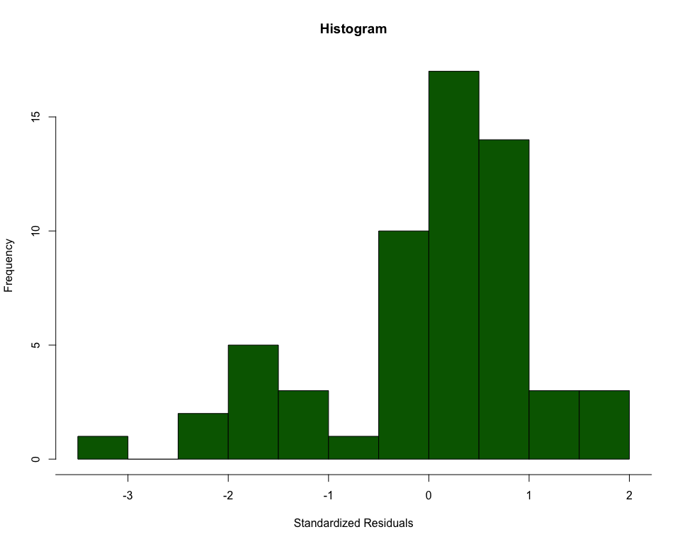

## 

## To create a histogram of the boxplot

boxplot(mystdres, horizontal = TRUE, col = 'darkgreen',  
 main = 'Boxplot', xlab = 'Standardized Residuals')

